实验报告（Lab 6）
姓名：丘绎楦 学号：1820221050
实验：Basic OSPF Configuration and Analysis
Lab 6-1 BASIC MULTIPLE AREA OSPF CONFIGURATION
Q6-1.1. Paste the screenshot of the created topology.
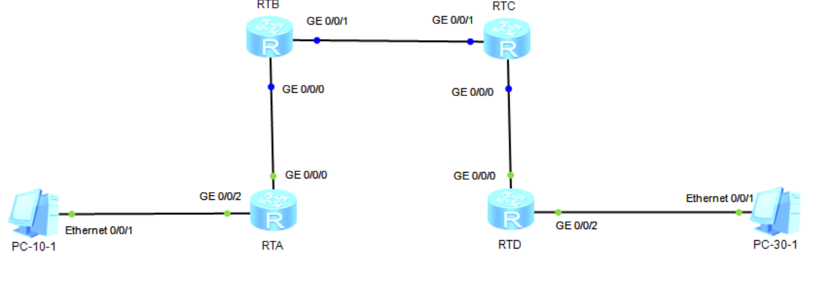
Q6-1.2. Paste the screenshots of the OSPF routing table, Link-State Database, OSPF neighbor, updates of the LSAs that the LSDB receives and route calculation statistics on the router RTA.
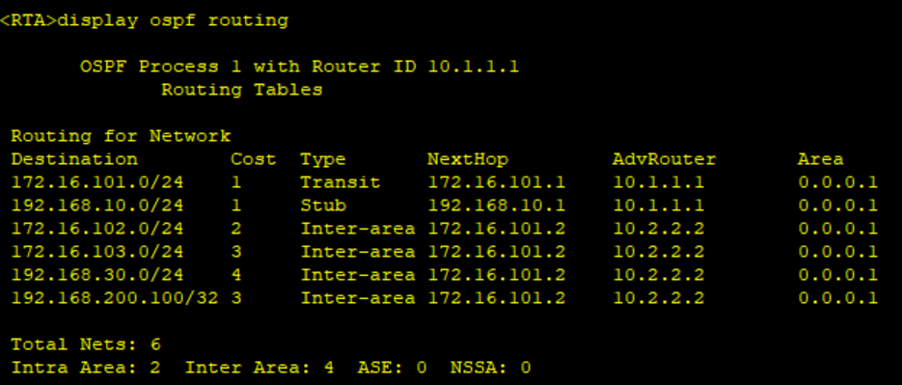
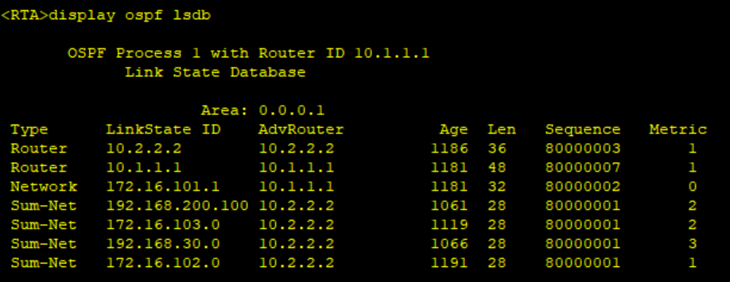
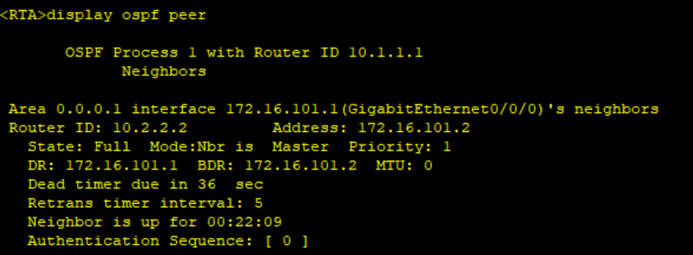
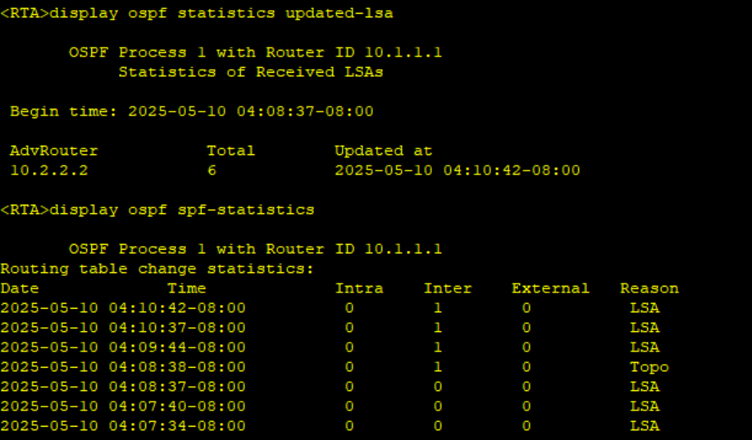
Q6-1.3. Paste the screenshots of the OSPF routing table, Link-State Database, OSPF neighbor, updates of the LSAs that the LSDB receives and route calculation statistics on the router RTB.
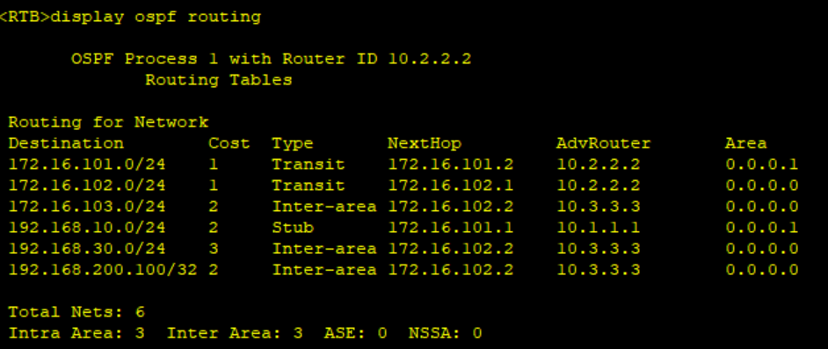
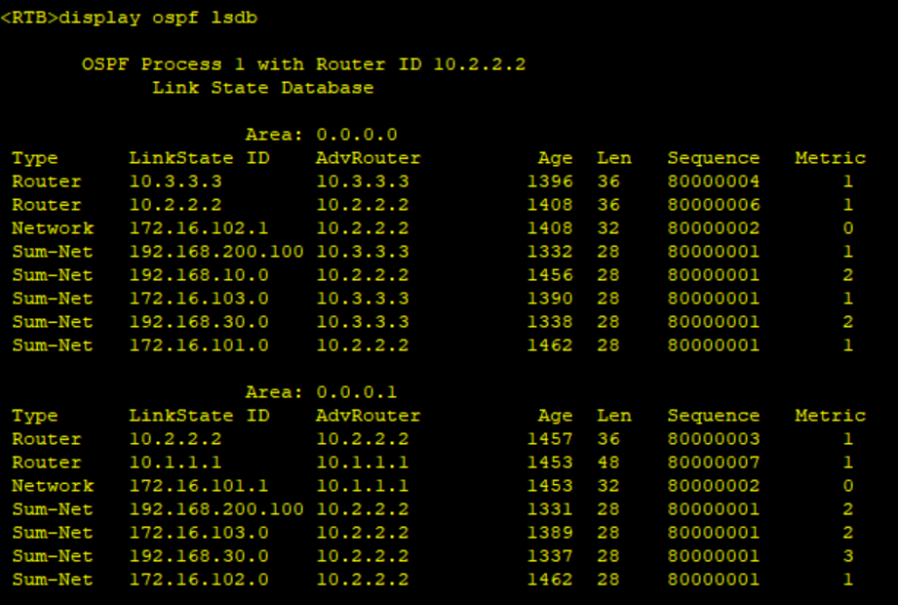
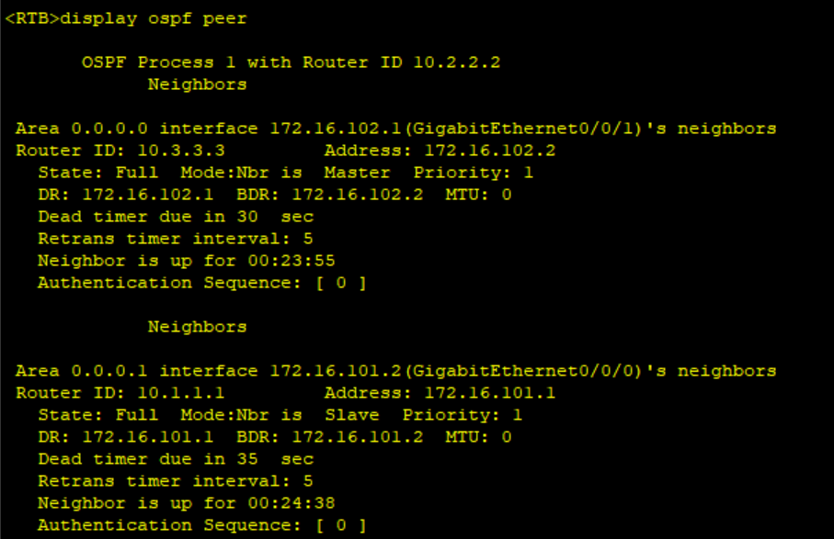
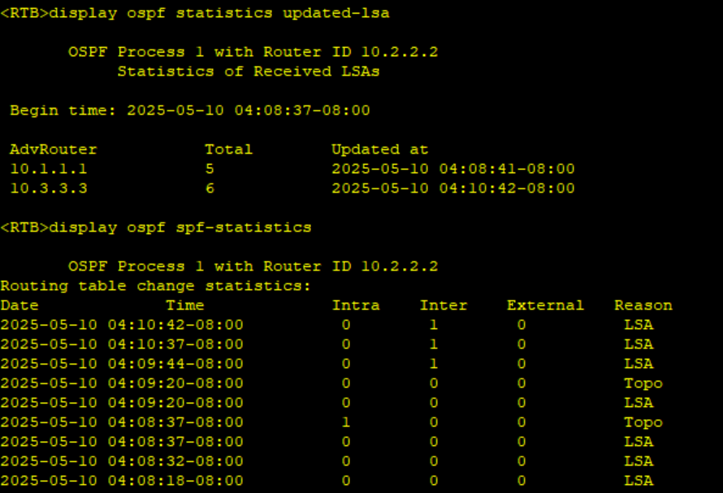
Q6-1.4. Paste the screenshots of the OSPF routing table, Link-State Database, OSPF neighbor, updates of the LSAs that the LSDB receives and route calculation statistics on the router RTC.
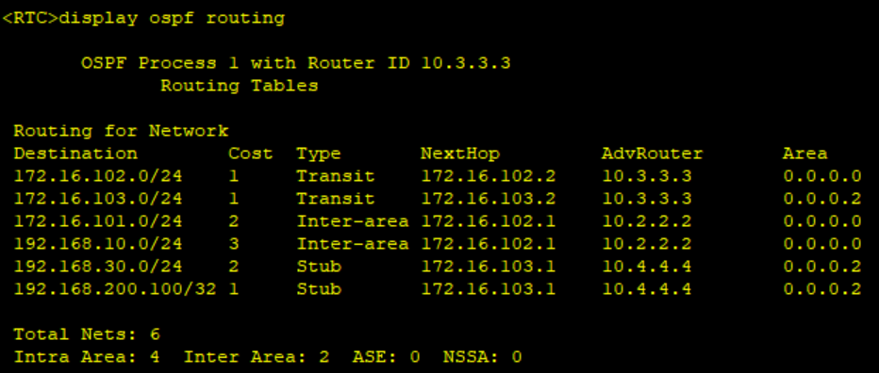
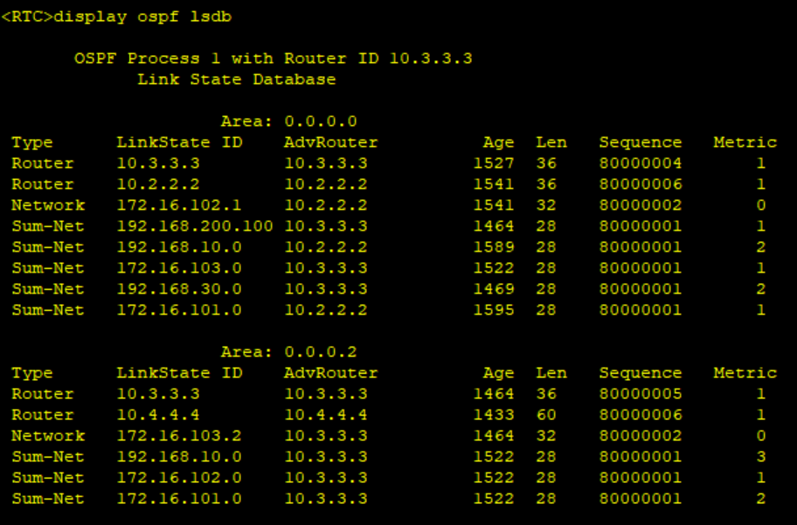
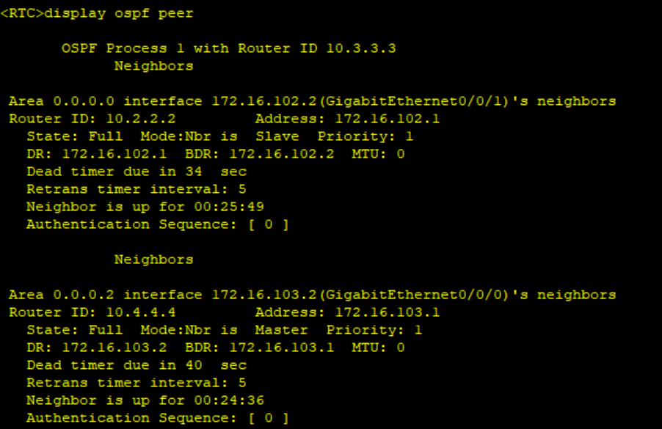
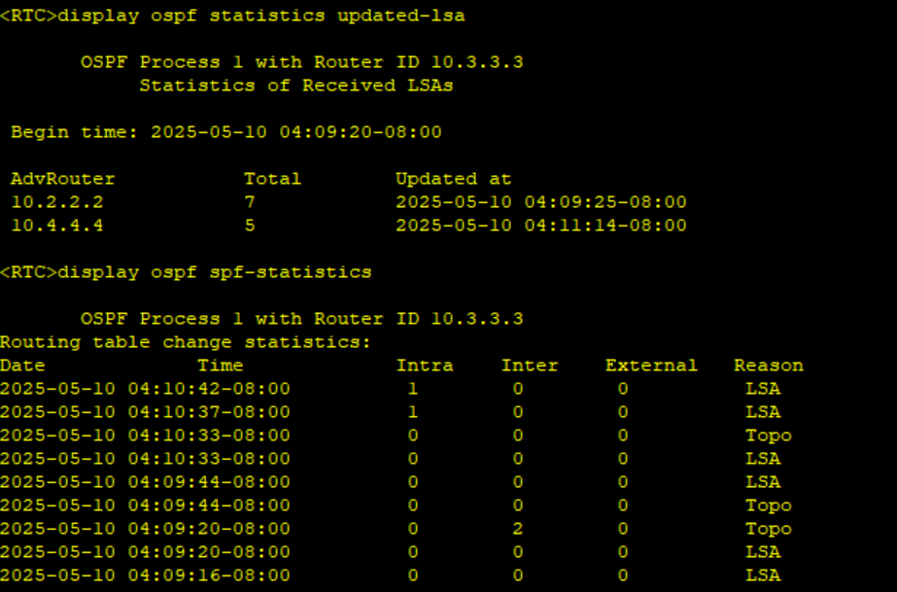
Q6-1.5. Paste the screenshots of the OSPF routing table, Link-State Database, OSPF neighbor, updates of the LSAs that the LSDB receives and route calculation statistics on the router RTD.
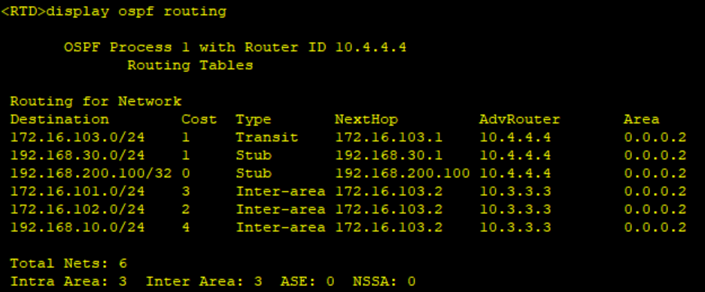
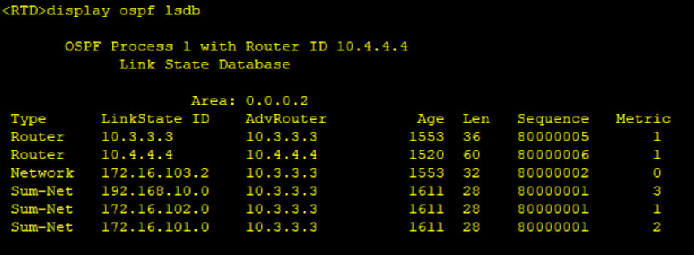
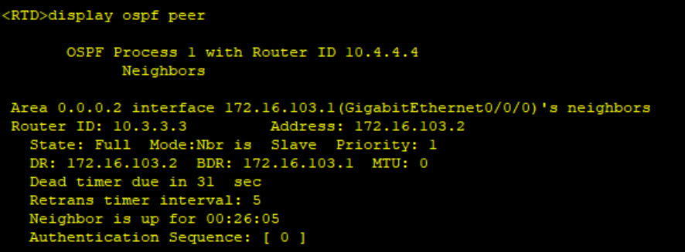
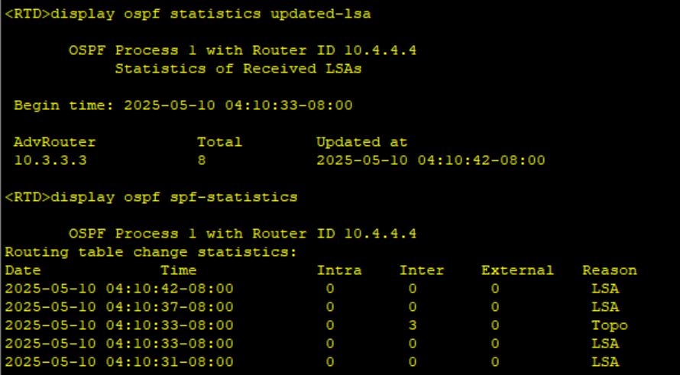
Q6-1.6. Can PC-10-1 and PC-30-1 ping each other? Please paste the screenshot of the ping result.
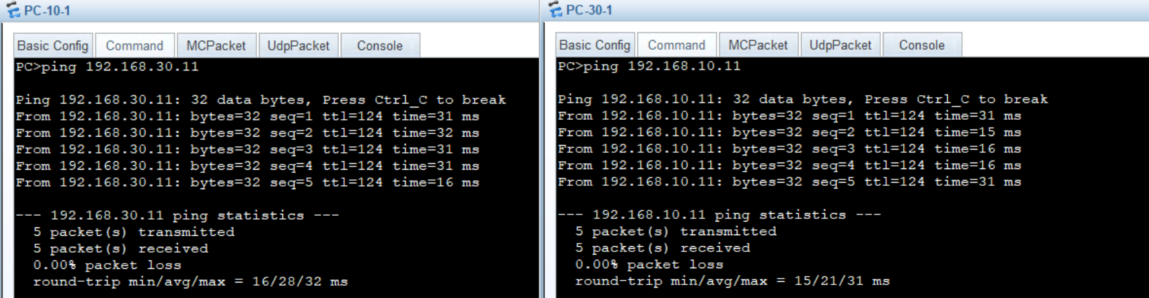
Q6-1.7. Can PC-10-1 and loopback 0 on RTD ping each other? Please paste the screenshot of the ping result.
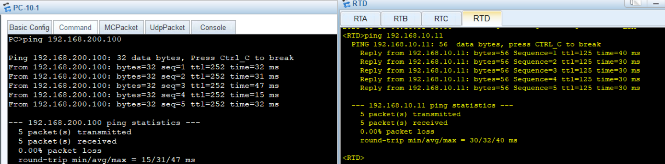
Q6-1.8. Please paste the screenshot of the result of command “tracert 192.168.30.11” issued from PC-10-1.
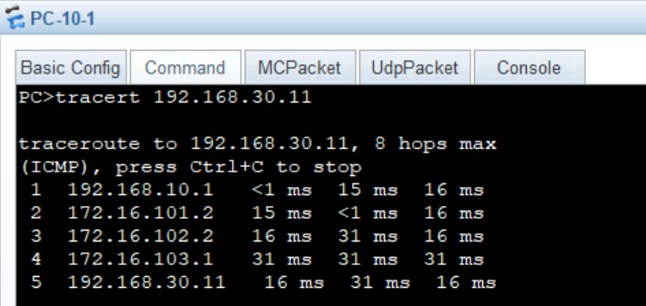
Q6-1.9. Just after configuring OSPF on RTA and RTB, what OSPF packets are exchanged between RTA and RTB? Please explain with the captured OSPF communications.
After configuring OSPF on RTA and RTB, the following OSPF packets are exchanged:
- Hello packets - to discover and establish neighbor relationships
- Database Description (DD) packets - to exchange LSDB summaries
- Link State Request (LSR) packets - to request specific LSAs
- Link State Update (LSU) packets - to send the requested LSAs
- Link State Acknowledgment (LSAck) packets - to acknowledge received LSAs
Q6-1.10. With the completion of the OSPF configurations on each router, how does RTA know that the network topology has changed? Please explain with the captured OSPF communications.
RTA learns about topology changes through:
- Hello packets that detect neighbor state changes
- LSU packets containing updated LSAs
- Periodic LSDB refreshes (every 30 minutes by default)
When a change occurs, neighboring routers flood LSU packets containing the updated LSA information throughout the area.

Q6-1.11. What OSPF packets are sent and received from the interface GE 0/0/0 and GE 0/0/1 on RTB? Paste the screenshot of the captured OSPF packets.
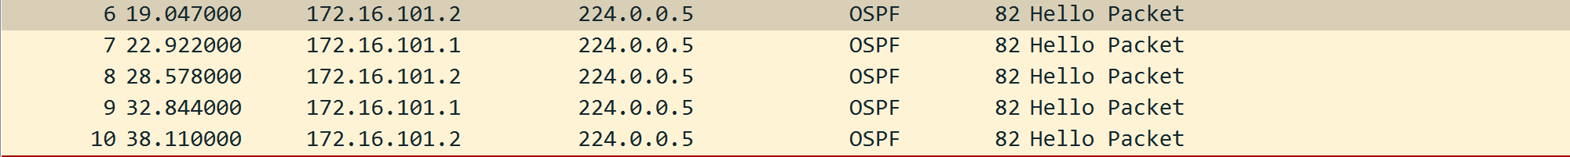
Q6-1.12. What OSPF packets are sent and received from the interface GE 0/0/0 and GE 0/0/1 on RTC? Paste the screenshot of the captured OSPF packets.
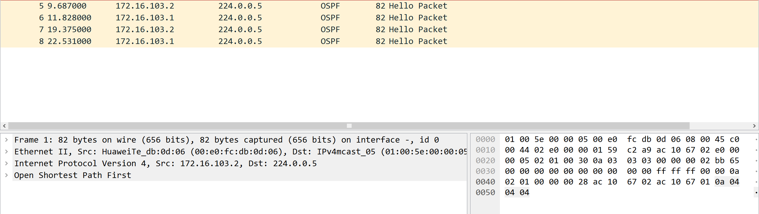
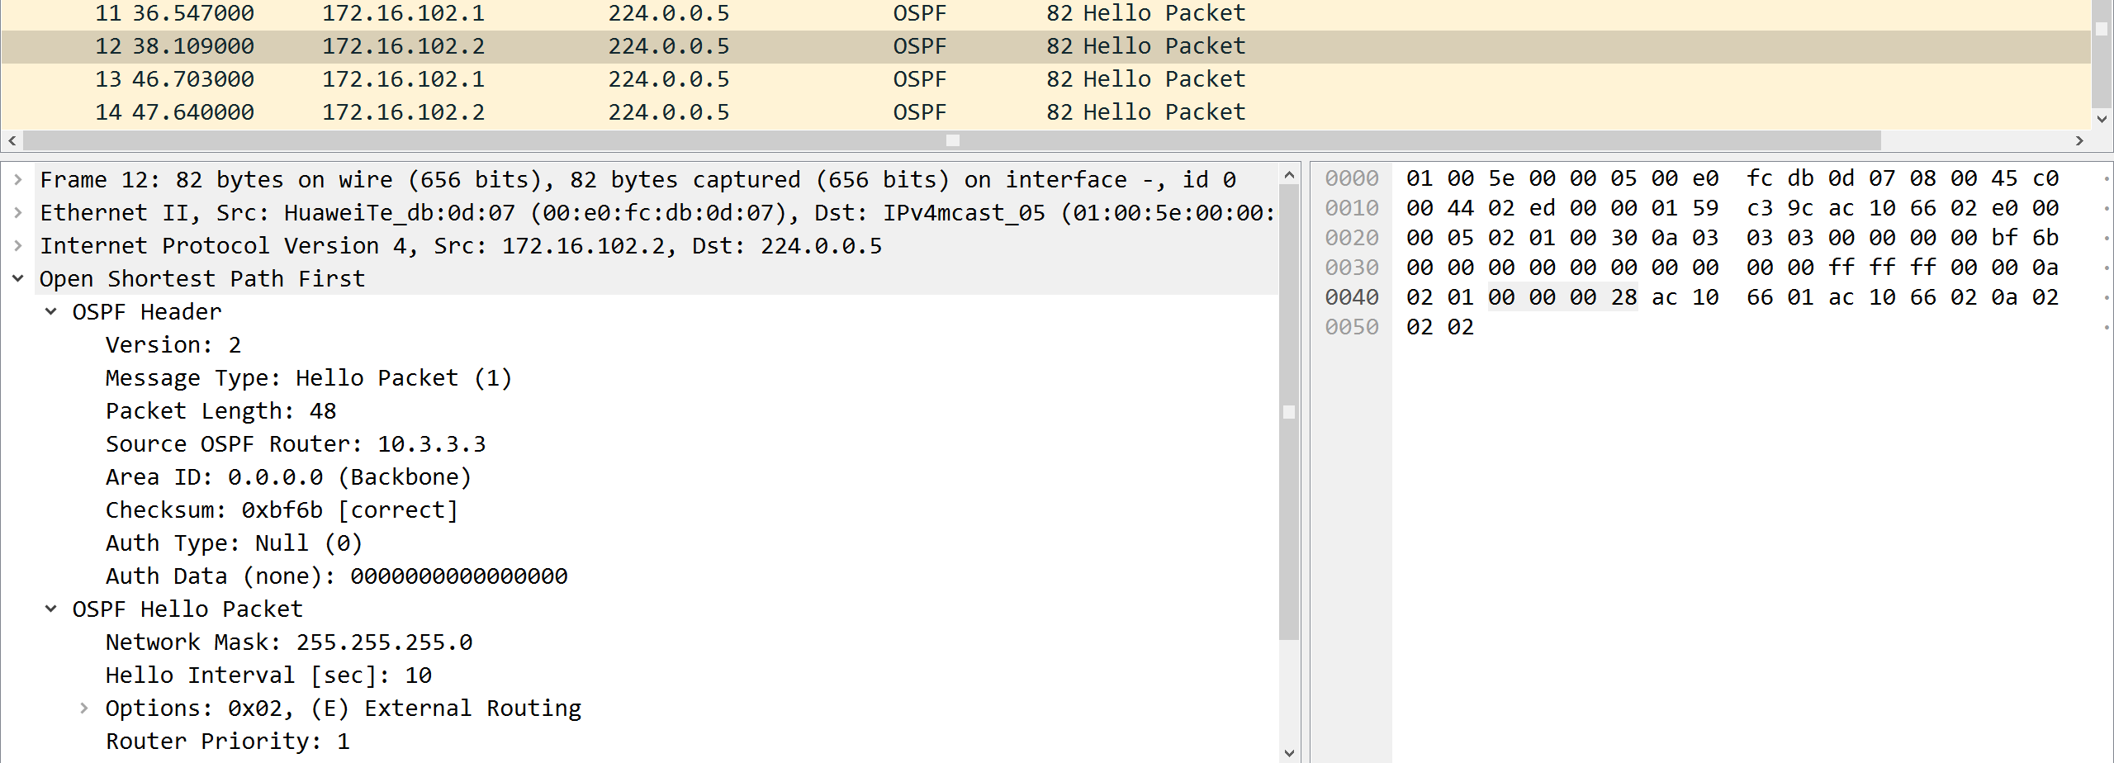
Q6-1.13. In what type of packet are the OSPF Link State Advertisements sent from the interface GE 0/0/0 on RTB transmitted? What are their LSA types? Paste the screenshot of the expanded information of the captured LSAs.
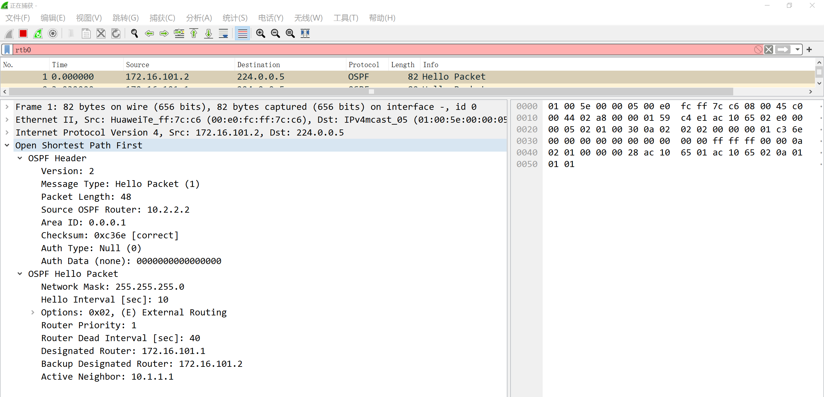
Q6-1.14. In what type of packet are the OSPF Link State Advertisements sent from the interface GE 0/0/1 on RTB transmitted? What are their LSA types? Paste the screenshot of the expanded information of the captured LSAs.
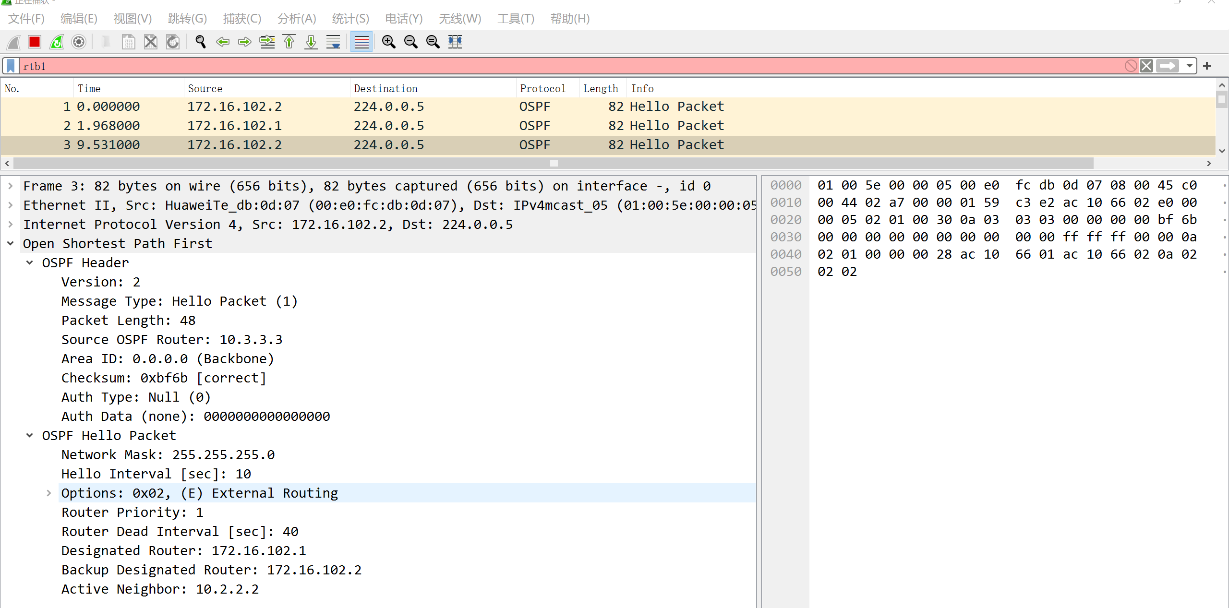
Q6-1.15. How are the Link State Advertisements in area 1 transmitted to area 2 through area 0? Please explain with the captured OSPF communications.
Area 1 LSAs are transmitted to Area 2 through Area 0 as follows:
- RTA floods Type 1 LSAs within Area 1
- RTB (ABR) converts relevant Type 1 LSAs to Type 3 Summary LSAs for Area 0
- RTC (ABR) converts these Type 3 LSAs for Area 2
- RTD receives the Type 3 LSAs in Area 2
Q6-1.16. How are the Link State Advertisements in area 2 transmitted to area 1 through area 0? Please explain with the captured OSPF communications.
Area 2 LSAs are transmitted to Area 1 through Area 0 as follows:
- RTD floods Type 1 LSAs within Area 2
- RTC (ABR) converts relevant Type 1 LSAs to Type 3 Summary LSAs for Area 0
- RTB (ABR) converts these Type 3 LSAs for Area 1
- RTA receives the Type 3 LSAs in Area 1

